**INTRODUCTION TO DATA MANAGEMENT**

(Project Semester January-April 2025)

***Interactive Food Price Inflation Dashboard (2004–2015)***

Submitted by

Paladugula Phani Chakra

Registration No: 12401493

Programme and Section: KM004

Course Code: INT217

Under the Guidance of

**18306-Savleen Kaur**

**Discipline of CSE/IT**

**Lovely School of Computer Science and Engineering**

**Lovely Professional University, Phagwara**



**CERTIFICATE**

This is to certify that Paladugula Phani Chakra bearing Registration no. 12401493 has completed INT217 project titled, **“Interactive Food Price Inflation Dashboard (2004–2015)”** under my guidance and supervision. To the best of my knowledge, the present work is the result of his/her original development, effort and study.

**Signature and Name of the Supervisor**

**Designation of the Supervisor**

**School of Computer Science And Engineering**

Lovely Professional University

Phagwara, Punjab.

Date:

**DECLARATION**

I, Paladugula Phani Chakra, student of Computer Science And Engineering under CSE/IT Discipline at, Lovely Professional University, Punjab, hereby declare that all the information furnished in this project report is based on my own intensive work and is genuine.

Date: Signature

Registration No. 12401493 Paladugula Phani Chakra

# Acknowledgement

I would like to express my sincere gratitude to everyone who supported me throughout the completion of this project. Special thanks to my mentor and faculty for their valuable guidance and encouragement. I also thank my friends and family for their constant support. This project helped me enhance my skills in data analysis and Excel dashboard creation.

# INTRODUCTION

The project focuses on creating an Excel dashboard to analyze food price inflation trends from the year 2004 to 2015. The goal is to help users understand how the prices of different food items have changed over time and to identify patterns or unusual changes. Using Excel, I created an interactive dashboard that allows users to select food items and years to dynamically update charts and statistics.

# 2. Source of Dataset

The dataset used in this project contains monthly prices of various food items from the year 2004 to 2015. The data was collected from a reliable online public data source that tracks historical food prices.

# 3. Dataset Preprocessing

Before creating the dashboard, I cleaned and formatted the dataset. This included:  
- Removing missing values  
- Converting dates into a consistent format  
- Organizing the data into a structured table  
- Sorting data by year and month  
This step helped in making the data ready for pivot tables and slicer functionality.

# 4. Analysis on Dataset

i. General Description  
The dataset includes food prices for each month from 2004 to 2015. The data covers various food items like rice, wheat, sugar, vegetables, etc. The main aim was to identify inflation trends and compare prices year-over-year.  
  
ii. Specific Requirements  
- Chart representation of average prices of each food item for each month  
- Show maximum and minimum prices of selected food  
- Show top 5 priced food items for a selected year  
- Make the dashboard interactive using slicers (for year and food)  
- Add a navigation panel to move between dashboard, raw data, and pivot tables  
  
iii. Analysis Results  
Using the dashboard:  
- Users can easily find the trend of any food item's price over the years  
- The max and min price panels instantly update when selecting a food item  
- The top 5 food items by price change dynamically when selecting a year  
- It’s easy to compare price fluctuations across months and years  
  
iv. Visualization  
Multiple charts and panels are used:  
- Line charts for average monthly prices

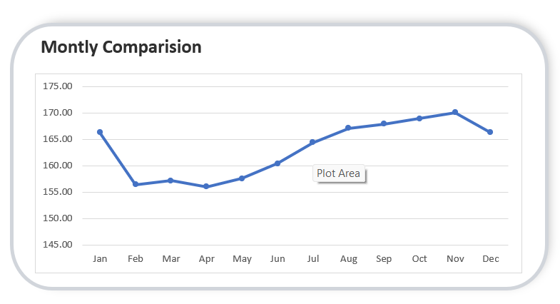

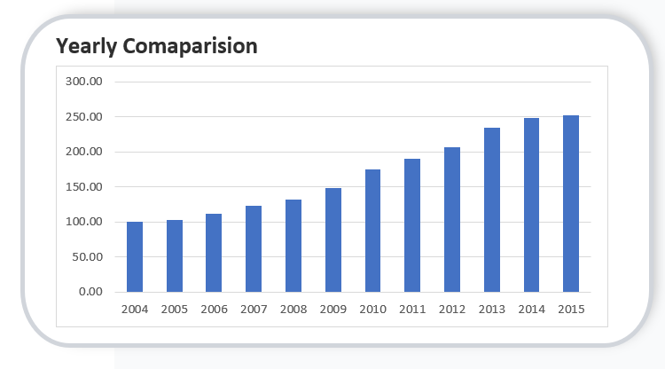  
- Slicers for filtering by year and food type  
- Navigation buttons to switch sheets  
All visuals update automatically based on slicer selections, making the dashboard user-friendly and informative.

# 5. Conclusion

This project helped me gain hands-on experience in Excel dashboard creation, data analysis, and visualization. I learned how to process data, use pivot tables, apply slicers, and create dynamic charts. The dashboard provides meaningful insights into food price trends over a long period.

# 6. Future Scope

- Add comparison with inflation rates from government statistics  
- Include forecasting using Excel formulas or Power BI integration  
- Improve UI design with icons and better formatting  
- Add more interactivity like drop-down menus or timelines

# 7. References

- Source of dataset: data.gov.in  
- Microsoft Excel documentation  
- YouTube tutorials and blogs for dashboard tips and tricks